Gloucestershire Registration Service
We understand that this can be a difficult time for you and others. Your Funeral Director has provided you with this leaflet to help guide you through the Registration process and to answer some of the questions you may have.

When Do I Register?
Deaths should be registered with 5 calendar days, unless the Coroner is involved. More information regarding the coroner is set out below.
Where Do I Register?
We have offices in Cheltenham, Gloucester, Stroud, Cinderford, Cirencester, Moreton in Marsh, Tewkesbury and now in Quedgeley. We aim to always have availability for appointments somewhere in the County. Registrations are by appointment only.
How Do I Make an Appointment?
The easiest way to make an appointment is to book online via the Gloucestershire County Council website: - https://gloucester.zipporah.co.uk/Registrars.Gloucester/ alternatively follow the links from the GCC home page. If there are no appointments available online please ring our booking line direct who will investigate other possible availability. The booking team can be contacted on 01452 425060.
Appointments cannot be made unless you have the Medical Certificate Cause of Death (MCCD) provided by the Doctor or Hospital, or you know it is signed and ready for you to collect.
If there is any coronial involvement, an appointment cannot be made until the relevant paperwork has been received from the coroner. The coroner will contact the next of kin and the Registration Service when the paperwork is ready.
In the case of a Coroner’s investigation or inquest, registration is not done immediately. The Coroner will issue Interim Death Certificates and the necessary paperwork to enable the funeral to take place. The Register Office will be instructed by the Coroner and send out other paperwork such as the Tell us Once registration information.

How Long will It Take?
We allow 40 minutes for a death registration. This includes the checking of the MCCD which may require us to contact the Surgery or Hospital. Sometimes these enquiries may take a little longer than expected.
Who Can Register?
Ideally a family member should register the death. Even if the only family member is outside of the County, it is preferable for them to register by declaration than delegate the duty to someone else.
If there are no family members or none that are able to register, the following people should register the death in the order stated:-
- Someone who was present at the death
- The “Occupier” of the place where the death occurred i.e. Care Home Manager, Hospital Bereavement Manager etc.
- The person who is arranging the funeral – this may be the Executor but being the Executor in itself is not a qualification for acting as the informant for death registration purposes.
What Should I Bring to the Appointment?
The Family will be asked to provide the following information:-
- Full name of the deceased and any previous names used including the maiden name
- Date and place of birth
- Home address with postcode
- Marital status of the deceased
- Full name of the deceased spouse/widow/er if applicable
- Current or latest occupation for the deceased and spouse/widow/er
- Whether or not the deceased or their spouse/widow/er were retired
We recommend that the Family bring any documents they have which pertain to the deceased such as a birth certificate, marriage certificate, drivers licence etc. These can then be used to check any information the family may not know with certainty. If we are given incorrect information and this does not come to light until after the registration has been signed the cost of making corrections is between £75 and £90 and may take several weeks to action.
How Much Does it Cost to Register?
Registration is free of charge however, death certificates are charged at £11 each. We accept cash or card but not American Express. They can be bought at the time of registration or later on via the Gloucestershire County Council. The cost is the same no matter when they are purchased.
How Do I Notify the DWP and other Government Departments and Agencies?
We have a service called Tell Us Once which is offered in conjunction with the Department of Work and Pensions. This service allows the family to notify all the different Government Departments and Agencies, both nationally and locally, in one transaction.
At the Registration appointment we issue the family with a unique reference number (Part 1) and explain to them what they need to do next (Part 2). They do not need to bring the Blue Badge or Bus Pass to the Registration appointment.
The organisations listed below may be able to offer support and advice:

www.gov.uk: search under ‘What to do after someone dies’ for helpful information about registering a death, arranging funerals and other important and helpful resources

Information about probate and inheritance tax
Telephone: 0300 123 1072
www.gov.uk/wills-probate-inheritance

Cruse Bereavement Care
Telephone: 01242 252518
Email: gloucestershire@cruse.org.uk
Website: www.gloucestershirecruse.org.uk

Samaritans
Telephone: 116123
Email: jo@samaritans.org
Website : www.samaritans.org

SANDS (Stillbirth and Neonatal death)
Telephone: 0808 164 3332
Email: helpline@sands.org.uk
Website: www.sands.org.uk

Survivors of Bereavement by Suicide
Telephone: 01452 371945
National Helpline: 0300 111 5065
Website: www.uksobs.org

Winston’s Wish (for children and young people)
Telephone: 01242 515157
Helpline: 08088 020021
Website: www.winstonswish.org

Your Circle, Gloucestershire
A directory to help you find you way around care and support and connect with people, places and activities in Gloucestershire
Website: www.yourcircle.org.uk

Gloucester Life Changes (for those approaching age 60 or over)
Telephone: 01452 881612
Email: lifechanges@redcross.org.uk
Website: www.ageuk.org.uk/gloucestershire/our-services/gloucester-life-changes

How Long will It Take?
We allow 40 minutes for a death registration. This includes the checking of the MCCD which may require us to contact the Surgery or Hospital. Sometimes these enquiries may take a little longer than expected.
Who Can Register?
Ideally a family member should register the death. Even if the only family member is outside of the County, it is preferable for them to register by declaration than delegate the duty to someone else. Please ring the booking team on 01452 425606 for information regarding registering by declaration.
If there are no family members or none that are able to register, the following people should register the death in the order set out below-
- Someone who was present at the death
- The “Occupier” of the place where the death occurred i.e. Care Home Manager, Hospital Bereavement Manager etc.
- The person who is arranging the funeral – this may be the Executor but being the Executor in itself is not a qualification for acting as the informant for death registration purposes.
- Note: During COVID 19 situation, Funeral Directors can register if instructed by a family member.

What Should I Bring to the Appointment?
You will be asked to provide the following information:-
- Full name of the deceased and any previous names used including the maiden name
- Date and place of birth
- Home address with postcode
- Marital status of the deceased
- Full name of the deceased spouse/widow/er if applicable
- Current or latest occupation for the deceased and spouse/widow/er
- Whether or not the deceased or their spouse/widow/er were retired

We recommend that the Family bring any documents they have which pertain to the deceased such as a birth certificate, marriage certificate, drivers licence etc. These can then be used to check any information the family may not know with certainty. If we are given incorrect information and this does not come to light until after the registration has been signed the cost of making corrections is between £75 and £90 and may take several weeks to action.
How Much Does it Cost to Register?
Registration is free of charge however, death certificates are charged at £11 each. We accept cash or card but not American Express. They can be bought at the time of registration or later on via the Gloucestershire County Council. The cost is the same no matter when they are purchased.
How Do I Notify the DWP and other Government Departments and Agencies?
We have a service called Tell Us Once which is offered in conjunction with the Department of Work and Pensions. This service allows the family to notify all the different Government Departments and Agencies, both nationally and locally, in one transaction.
At the Registration appointment we issue the family with a unique reference number (Part 1) and explain to them what they need to do next (Part 2). They do not need to bring the Blue Badge or Bus Pass to the Registration appointment.

Gloucestershire Register Office
St George’s Road
CHELTENHAM
GL50 3EW

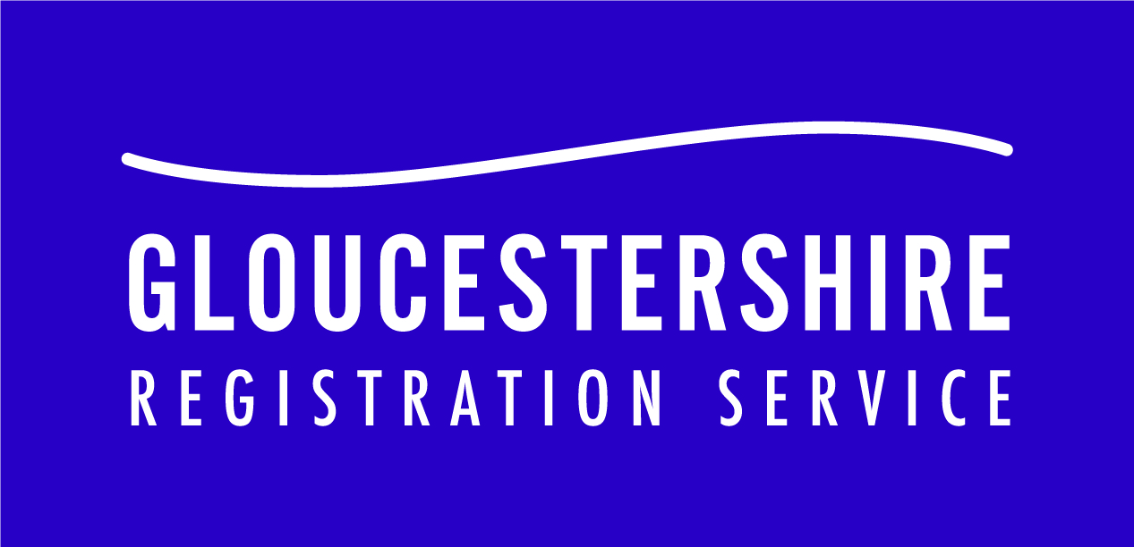

Registering a Death

Gloucestershire Register Office
St George’s Road
CHELTENHAM
GL50 3EW
Tel: 01452 425060

deceased such as a birth certificate, marriage certificate, drivers licence etc. These can then be used to check any information the family may not know with certainty. If we are given incorrect information and this does not come to light until after the registration has been signed the cost of making corrections is between £75 and £90 and may take several weeks to action.

How Much Does it Cost to Register?
Registration is free of charge however, death certificates are charged at £11 each. We accept cash or card but not American Express. They can be bought at the time of registration or later on via the Gloucestershire County Council website. The cost is the same no matter when they are purchased. The Registering Officer will advise you with regard to the number of certificates which may be required.
How Do I Notify the DWP and other Government Departments and Agencies?
We have a service called Tell Us Once which is offered in conjunction with the Department of Work and Pensions. This service allows the family to notify all the different Government Departments and Agencies, both nationally and locally, in one transaction.
At the Registration appointment we issue you with a unique reference number and explain to you what you will need to do next to complete the process. You do not need to bring the Blue Badge or Bus Pass to the Registration appointment.

Copy certificates, appointment bookings
and information on all services offered by
Gloucestershire Registration Service can
be found on our website:

www.gloucestershire.gov.uk/registration

Gloucestershire Register Office
St George’s Road
CHELTENHAM
GL50 3EW
Tel: 01452 425060

Gloucestershire Register Office
St George’s Road
CHELTENHAM
GL50 3EW
Tel: 01452 425060

